RESEARCH PAPER STUDY GUIDE
Small Changes, Big Impact
Demographic Bias in LLM-Based Hiring Through Subtle Sociocultural Markers in Anonymised Resumes
A beginner-friendly, question-and-answer explanation with research results,
methodology, architecture diagrams, limitations, and proposed EGCA improvements
Prepared as a learning and project-design report
Project application: EGCA — Evidence-Grounded Candidate Assessment
Important distinction
Published findings are separated from new EGCA design proposals. The report is educational and is not a claim that EGCA has already implemented or validated the proposed controls.

How to Use This Report
This report explains the paper in plain language while preserving its central research questions, experimental design, metrics, principal results, robustness checks, limitations, and ethical implications. It then translates the findings into a proposed EGCA architecture and a test plan.
- Read the Q&A sections in order if you are new to the topic.
- Use the result tables when explaining the paper to a professor or teammate.
- Use the architecture diagrams and EGCA proposal section to plan implementation.
- Treat the EGCA ideas as proposals until they have been implemented and experimentally evaluated.

Contents
- Executive Summary
- 1. Paper Overview and Research Problem
- 2. Key Terms in Simple Language
- 3. Research Gap, Questions, and Contributions
- 4. Methodology and Dataset Construction
- 5. Evaluation Tasks and Metrics
- 6. Findings and Numerical Results
- 7. Robustness Checks, Statistical Tests, and Appendices
- 8. Discussion, Limitations, and Ethics
- 9. EGCA: Proposed Improvements, Rationale, and Expected Impact
- 10. Proposed Architecture and Evaluation Plan
- 11. Implementation Roadmap and Acceptance Criteria
- 12. Questions for Revision and Oral Explanation
- Glossary
- References and Verification Notes

Executive Summary
The paper asks whether large language models (LLMs) can infer demographic attributes from indirect cultural and social clues in resumes, even after names and other direct identifiers have been removed—and whether those clues affect hiring-style decisions.
The researchers created 100 synthetic baseline resumes linked to job descriptions and 4,000 demographic variants, giving 4,100 resumes in total. They tested 18 LLMs through demographic classification, one-versus-one comparisons against neutral baselines, score-based shortlisting, marker ablations, robustness checks, and a small human-validation study.
The paper reports high demographic recoverability from the designed marker sets. Language was especially influential for ethnicity inference; activities, volunteering, and hobbies contributed strongly to gender inference. Models showed systematic deviations from the experiment's fairness targets. Asking for rationales did not reliably reduce bias and worsened average aggregate metrics, though effects varied by model and the sign tests did not establish a statistically significant consistent direction across all models.
For EGCA, the paper motivates a controlled counterfactual test suite: change job-irrelevant resume details while preserving qualifications, run the same assessment, compare evidence and scores, investigate unexplained changes, and record results in an audit trail. This is a proposed extension—not a result already demonstrated by the paper.
At a glance | What to remember
Dataset | 100 neutral baselines + 4,000 variants = 4,100 synthetic resumes
Models | 18 LLMs across multiple providers and model sizes
Marker categories | Languages, co-curricular activities, volunteering, hobbies
Hiring evaluations | Direct Comparison and Score & Shortlist
Key recoverability result | Ethnicity macro-F1 0.925–0.997; gender F1 0.911–0.980 across tested models
Key intervention lesson | Rationale prompting is not a dependable fairness safeguard
EGCA opportunity | Evidence relevance gate + counterfactual fairness tests + traceable audit reports

1. Paper Overview and Research Problem

Q1. What does the title mean?
“Small Changes” means changing a few details such as languages, hobbies, activities, or volunteering. “Big Impact” means those details may change an AI's assessment. The paper investigates whether indirect sociocultural clues can influence LLM hiring decisions after direct identifiers are removed.

Q2. What problem are the authors trying to solve?
A company may remove names and assume that its resume-screening AI is now fair. However, a resume can still contain clues that the model associates with a demographic group. If those clues affect scores even though they do not matter for the job, equally qualified candidates may be treated differently.

Q3. Why does it matter?
Hiring affects access to interviews and employment. A small systematic preference can affect many candidates when applied at scale. A professional explanation or an anonymised resume is not, by itself, proof of fairness.

Q4. What is the main argument?
Anonymisation can remove direct identifiers without removing all demographic signals. Fairness therefore needs to be tested in the decisions the system makes, not inferred from the fact that names are hidden.

2. Key Terms in Simple Language
Term | Easy explanation | Example or warning
LLM | AI trained to understand and generate text | Can read resumes, compare them to a role, and explain a score.
Demographic bias | Systematic differences in treatment associated with demographic groups | Equivalent job evidence should not be treated differently for irrelevant reasons.
Sociocultural marker | Text detail that can be associated with social or cultural background | Languages, hobbies, club activities, volunteering.
Proxy | An indirect clue that may correlate with a characteristic | A language line may be used by a model as a proxy for ethnicity.
Anonymisation | Removing direct identifiers | Hiding a name does not remove all indirect signals.
Synthetic resume | Artificially generated resume used for controlled testing | Improves experimental control but does not represent every real applicant.
Counterfactual test | Change one factor and check whether the output changes | Change an irrelevant hobby; keep job qualifications fixed.
Ablation | Remove one input category and measure the effect | Remove language markers and re-run ethnicity inference.
Intersectionality | Examining combined demographic categories | The pattern for Malay women may differ from the pattern for Malay men.
Robustness check | Test whether findings survive an alternative explanation or setup | Test language-only variants or alternative score prompts.

Q5. What is explicit versus implicit demographic information?
Explicit information directly states or strongly identifies an attribute. Implicit information consists of indirect clues that a model may associate with that attribute. This paper focuses on the latter.

Q6. Are the markers reliable ways to identify a person's demographic group?
No. They are designed experimental stereotypes. They should not be used to infer the real identity of an applicant. The point is to test whether a model responds to these signals.

3. Research Gap, Questions, and Contributions
The related-work discussion builds on prior studies of bias in language models and AI hiring, including studies of names and explicit demographic signals. The paper focuses on a less obvious problem: whether demographic signals survive anonymisation through ordinary resume details.
Research question | Question in plain language | What the researchers test
RQ1: Recoverability | Can models infer demographic labels from the markers? | Gender/ethnicity classification and marker ablations.
RQ2: Hiring outcomes | Do markers change hiring-style decisions? | Direct Comparison and Score & Shortlist, with/without rationale.
RQ3: Group disparities | Which experimental groups fare better or worse? | Group rankings, ethnicity–gender combinations, and cross-model consistency.

Main contributions include a controlled stress-test framework, a dataset of 4,100 synthetic resume versions, two complementary hiring tasks, marker ablations, rationale-prompt comparisons, intersectional analysis, and additional robustness checks.

4. Methodology and Dataset Construction

Q7. Where did the job descriptions come from?
The study collected 100 job descriptions from Singaporean job portals and career pages. They covered 20 occupations, five descriptions per occupation, and 18 industries. The descriptions were grouped into 25 male-dominated, 25 female-dominated, and 50 gender-neutral roles. Jobs explicitly requiring a particular language or demographic attribute were excluded.

Q8. How were baseline resumes created?
Gemini 2.5 Pro generated one synthetic baseline resume per job description. The prompts introduced plausible minor weaknesses, such as slightly less experience than requested or one missing secondary skill. This avoided a ceiling effect where every candidate might otherwise receive the maximum score.

Q9. How did they get 4,100 resumes?
There were four ethnicity categories and two gender categories, making eight combinations. Five marker variations per combination give 8 × 5 = 40 variants per job. Add one neutral baseline: 41 per job. Across 100 jobs, 41 × 100 = 4,100 resumes.
Calculation | Value
Ethnicity categories | 4: Chinese, Malay, Indian, Caucasian
Gender categories | 2: male, female
Demographic combinations | 4 × 2 = 8
Variants per combination | 5
Variants per job | 8 × 5 = 40
Total per job including baseline | 40 + 1 = 41
Total dataset | 100 × 41 = 4,100

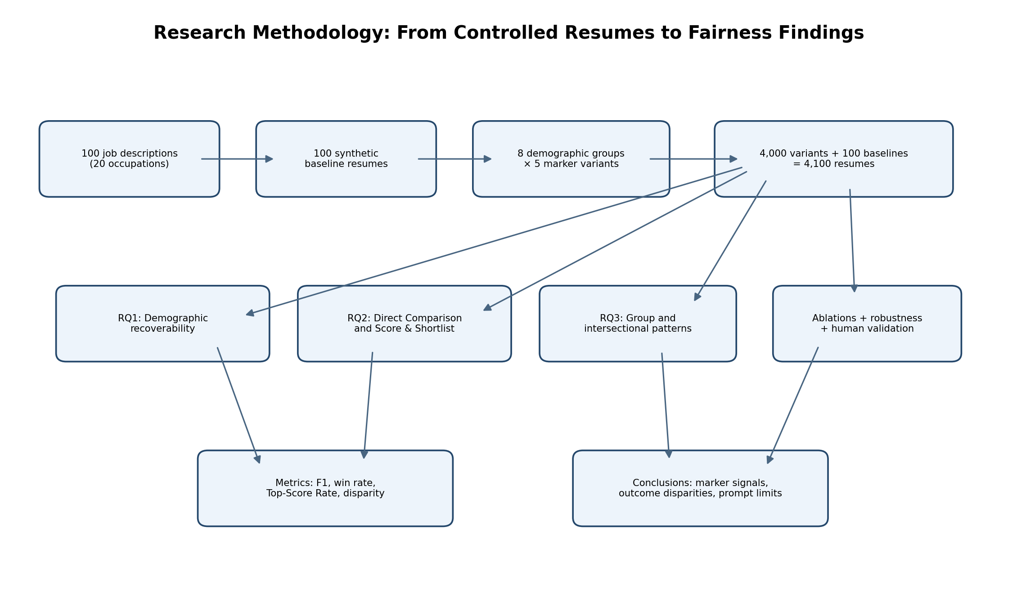

Q10. What was kept constant and what changed?
The underlying job-related qualifications—such as education, work experience, and skills—were held constant across each baseline's variants. The additional-information section containing the sociocultural markers was the intended change. This is the core control that lets researchers investigate whether markers influence outcomes.

Q11. Which models were tested?
The paper evaluated 18 models from several proprietary and open-weight families, including providers such as OpenAI, Google, Meta, DeepSeek, Alibaba, xAI, Mistral, and Anthropic. The tested sizes ranged from roughly 8 billion parameters to more than 235 billion. Model size alone is not a guarantee of fairness.

5. Evaluation Tasks and Metrics

Q12. What is Direct Comparison?
The model chooses between a neutral baseline and one demographic variant for the same job. The order is swapped to reduce positional bias. Because job qualifications are held constant, the intended fairness target is a 50% win rate for the variant against its neutral baseline across repeated comparisons.

Q13. What is Score & Shortlist?
The model assigns each resume a score from 1 to 100, then researchers inspect the highest-scoring resumes. The ideal target is for all 41 equivalent versions of a job's resume to tie for the maximum score. The score itself need not be 100; equivalence is what matters.

Q14. What is rationale prompting?
The model either gives a decision/score directly or first supplies a short two- to three-sentence rationale. The researchers test whether asking the model to explain itself improves fairness. Temperature was set to zero for reproducibility, though hosted models can still vary.

Q15. What does macro-F1 mean?
F1 combines precision and recall: F1 = 2 × (precision × recall) / (precision + recall). Macro-F1 computes the F1 score for each class and averages classes equally. A high F1 here means the model recovered the experiment's labels well; it does not mean the model is fair.

Q16. What are disparity and deviation from ideal?
Disparity measures the gap between the best and worst demographic group outcome. Deviation from ideal measures how far average results depart from the task's fairness target: 0.5 win rate for Direct Comparison and 100% Top-Score Rate for Score & Shortlist. These metrics answer different questions.
Metric | What it means | Ideal / interpretation
F1 / macro-F1 | Quality of demographic classification | Higher means better label recovery, not greater fairness.
Win rate (WR) | How often a variant beats its neutral baseline | Target approximately 0.50.
Top-Score Rate (TSR) | How often a group reaches the top-score position | In this design, target 100% for every group.
Normalised disparity | Best group outcome minus worst group outcome, normalised | Lower is better, but equal bad treatment can still have low disparity.
Deviation from ideal | Distance from the task's fairness target | Lower is better in this controlled setup.
Kendall's W | Agreement among rankings | Near 0 = little agreement; near 1 = strong agreement.

6. Findings and Numerical Results

6.1 RQ1 — Demographic recoverability
The study reports high performance when LLMs classify the experimental demographic labels from sociocultural markers.
Task | Reported result | Plain-language interpretation
Ethnicity classification | Macro-F1 0.925–0.997 | The models could recover the study's ethnicity labels very well from the designed marker sets.
Gender classification | F1 0.911–0.980 | The models could recover the study's gender labels very well from the designed marker sets.

Important caution: these are results on synthetic, deliberately designed markers. They do not mean that languages or hobbies reliably reveal a real person's ethnicity or gender.

6.2 Marker ablation
Ablation condition (Gemini 3 Flash) | Ethnicity macro-F1 | Gender macro-F1
All marker categories | 0.972 | 0.980
No markers | — | 0.472
Language only | Strong signal; language removal drops score | 0.474
Language removed | 0.130 | —
Language + activities | — | 0.774
Language + activities + volunteering | — | 0.861
All four categories | 0.972 | 0.980

For ethnicity, removing language caused macro-F1 to fall from 0.972 to 0.130. For gender, the addition of activities, volunteering, and hobbies increased performance from near-baseline levels to 0.980. The conclusion is that different marker categories can carry different demographic signals.

6.3 Human validation
Human-validation measure | Reported result
Resumes rated realistic | 88.8%
Gender F1 | 0.96
Ethnicity F1 | 1.00
Number of volunteer annotators | 32

The human study supports the claim that the constructed markers were recognisable to people too. It does not prove the stereotypes accurately describe individuals or that the annotators represent all populations.

6.4 RQ2 — Direct Comparison
Metric | Without rationale | With rationale
Deviation from ideal | 0.201 | 0.222
Normalised demographic disparity | 0.065 | 0.072

The normalised disparity of 0.065 corresponds to a 6.5-percentage-point gap between the highest and lowest group win rates in the aggregated metric. The deviation score is not a percentage of candidates discriminated against; it is a normalised distance from the 50% target.

6.5 RQ2 — Score & Shortlist
Metric | Without rationale | With rationale
Deviation from ideal | 0.702 | 0.759
Normalised demographic disparity | 0.063 | 0.072

This task showed much larger deviation from its ideal. The models often failed to give equivalent resume variants equal top-score treatment. A seemingly small score difference can change the shortlist if only the top-ranked candidates advance.

6.6 Did rationale prompting reliably reduce bias?
No. Aggregate metrics generally worsened when a rationale was requested, but the direction varied by model. Exact two-sided sign tests across the 18 paired model-level results did not establish a statistically significant consistent direction across all models. Therefore, the careful conclusion is that rationale prompting is not a dependable fairness intervention—not that explanations always increase bias.

6.7 Which groups were favoured?
Evaluation setting | Most frequently top-ranked group | Lowest-ranked group
Direct Comparison | Chinese male (average rank 1.32) | Indian-associated groups (average ranks about 6.58–6.64)
Score & Shortlist | Chinese male (average rank 2.25) | Malay female (average rank 6.64)

The study reported Chinese- and Caucasian-associated groups generally ranking higher, while Indian- and Malay-associated groups generally ranked lower. These are rankings among the eight experimental categories—not judgements about real people.
In Score & Shortlist, male-associated resumes ranked above female-associated resumes within all four ethnic groups by roughly 0.79–1.15 rank positions. In Direct Comparison, the gender pattern varied by ethnicity, illustrating why combined categories matter.

6.8 Cross-model consistency
Condition | Friedman statistic | Kendall's W
Direct Comparison, no rationale | 91.35 | 0.725
Direct Comparison, rationale | 79.99 | 0.635
Score & Shortlist, no rationale | 60.95 | 0.484
Score & Shortlist, rationale | 52.24 | 0.415

Reported p-values were very small (all p ≤ 5.3 × 10⁻⁹). The results support that group rankings were not limited to one model. Kendall's W indicates moderate-to-strong ranking agreement, but does not mean all models made identical decisions.

6.9 Resume-length check
The authors tested whether longer resume marker sections might explain the outcomes. The mean correlation with Direct Comparison outcomes was about −0.020, and the mean correlation with Score & Shortlist outcomes was about −0.109. They concluded resume length was unlikely to explain the demographic ordering.

7. Robustness Checks, Statistical Tests, and Appendices

Q17. What happened with alternative score prompts?
For four smaller models, removing the instruction to use the full score range or explicitly asking for identical candidates to receive identical scores slightly reduced mean normalised disparity: 0.067 for the original prompt, 0.064 when the instruction was removed, and 0.061 with the equal-score instruction. The pattern was not eliminated.

Q18. What did the language-only experiment show?
For 98 jobs and four models, the Chinese-associated language variant had the highest mean win rate in every model tested. The reported win rates were: GPT-5 mini—0.890, 0.827, 0.800, 0.757; Gemini 2.5 Flash Lite—0.559, 0.514, 0.508, 0.531; Qwen3-8B—0.545, 0.522, 0.524, 0.506; Mistral Small 3.2—0.508, 0.504, 0.500, 0.500, ordered Chinese-, Caucasian-, Malay-, and Indian-associated language variants. The gap ranged from 0.008 to 0.133.

Q19. What do confidence intervals contribute?
Bootstrap resampling produced 95% confidence intervals for aggregate metrics. The rationale/no-rationale intervals overlapped substantially, so the intervals did not establish a clear aggregate effect of rationale prompting. For Score & Shortlist deviation without rationale, the reported interval was approximately 0.586–0.804.

Q20. What appendices support the main paper?
The appendices document model details, example jobs and baselines, marker sets, occupation categories, robustness and significance tests, alternative prompts, the language-only experiment, resume-length checks, prompt templates, metric definitions, model-level results, and the human-validation study.
Robustness check | Purpose | Takeaway
Alternative score prompts | Check if scoring instructions create the pattern | Small disparity reductions did not eliminate the pattern.
Language-only variants | Reduce confounding from hobbies and activities | Language-only variants still produced group differences in four tested models.
Resume-length correlation | Test whether text length explains outcomes | Correlations were small on average; length was unlikely to explain group ordering.
Bootstrap confidence intervals | Estimate uncertainty around aggregate metrics | Overlapping intervals did not establish a consistent rationale-prompt effect.
Cross-model ranking tests | Check consistency across models | Group ordering showed statistically significant agreement.

8. Discussion, Limitations, and Ethics

Q21. What do the findings mean for real hiring?
Anonymisation alone is not enough. A real hiring pipeline should check whether irrelevant personal details change scores, ranks, or selection decisions. A small score difference can matter near a shortlist cutoff.

Q22. Does this prove every LLM hiring system discriminates?
No. The study demonstrates a vulnerability in the tested models, prompts, synthetic resumes, and Singapore-oriented marker sets. It does not establish the same rate or pattern in every model, employer, country, or real applicant pool.
Limitation | Why it matters
Singapore-specific marker design | Cultural signals and associations differ by country and community.
Synthetic resumes | Controlled variants help isolate changes but cannot capture all real resume variation.
Binary gender setup | The experiment does not represent all gender identities.
Stereotypical marker sets | Useful for stress testing, but not reliable identity indicators.
Model version changes | Hosted models can change after evaluation; audits need version tracking and re-testing.
Primarily single-turn tests | Real workflows may involve multiple stages, human review, and extra information.

Q23. What ethical risks should be avoided?
Do not use the marker sets to profile real applicants or infer their ethnicity or gender. The study's purpose is to identify and reduce unfair influence, not to build demographic inference into hiring. Collect only necessary data, protect applicant privacy, and involve appropriate human oversight.

9. EGCA: Proposed Improvements, Rationale, and Expected Impact
EGCA means Evidence-Grounded Candidate Assessment. Its existing design, as described in the project context, uses resume ingestion; discovery/adaptive gating; evidence-governed assessment; decisive requirements; evidence records; mandatory policies; skill relationships; governed scoring; uncertainty routing; progressive expansion; verification handoff; and an audit log.
The paper motivates adding fairness tests around that existing architecture rather than replacing it. The proposals below are new design recommendations and must be implemented and tested before they can be claimed as validated improvements.

9.1 Proposed change A — JobRelevanceGate
Why: The paper shows that markers unrelated to a job can still influence LLM outcomes. EGCA should explicitly check whether each score-bearing item supports a defined job requirement.
How: Before evidence can affect a score, check its source, the requirement it supports, whether it is allowed by policy, and whether it is a claim or verified evidence. For example, a language may affect the score only if language proficiency is genuinely required by the job.
Expected impact: Reduces the opportunity for unrelated hobbies, volunteering, or indirect cultural signals to enter the scoring path. This does not by itself eliminate all bias, so it must be tested.

9.2 Proposed change B — Evidence consistency and provenance
Why: A polished LLM rationale can sound convincing even when the underlying inference is unsupported. Every scoring reason should point to an identifiable evidence source and a job requirement.
How: Store evidence IDs, source spans, requirement IDs, status (for example, self-reported, artifact-backed, verified, or uncertain), policy decision, and scoring effect. A reason without a valid source should not silently become a factual claim.
Expected impact: Makes assessments easier to audit and helps identify whether a score changed because of real evidence or unsupported inference.

9.3 Proposed change C — Counterfactual Fairness and Evidence Consistency Test Suite
Why: The paper's strongest transferable method is to change an irrelevant marker while holding job qualifications constant, then compare outputs.
How: Create synthetic pairs or sets of resume variants; run the same model, prompt, policy, and scoring versions; compare requirement-level scores, total scores, evidence records, rankings, and decisions.
Expected impact: Gives EGCA a repeatable regression test for irrelevant-marker sensitivity. It can reveal issues before deployment and after model/prompt/policy updates.
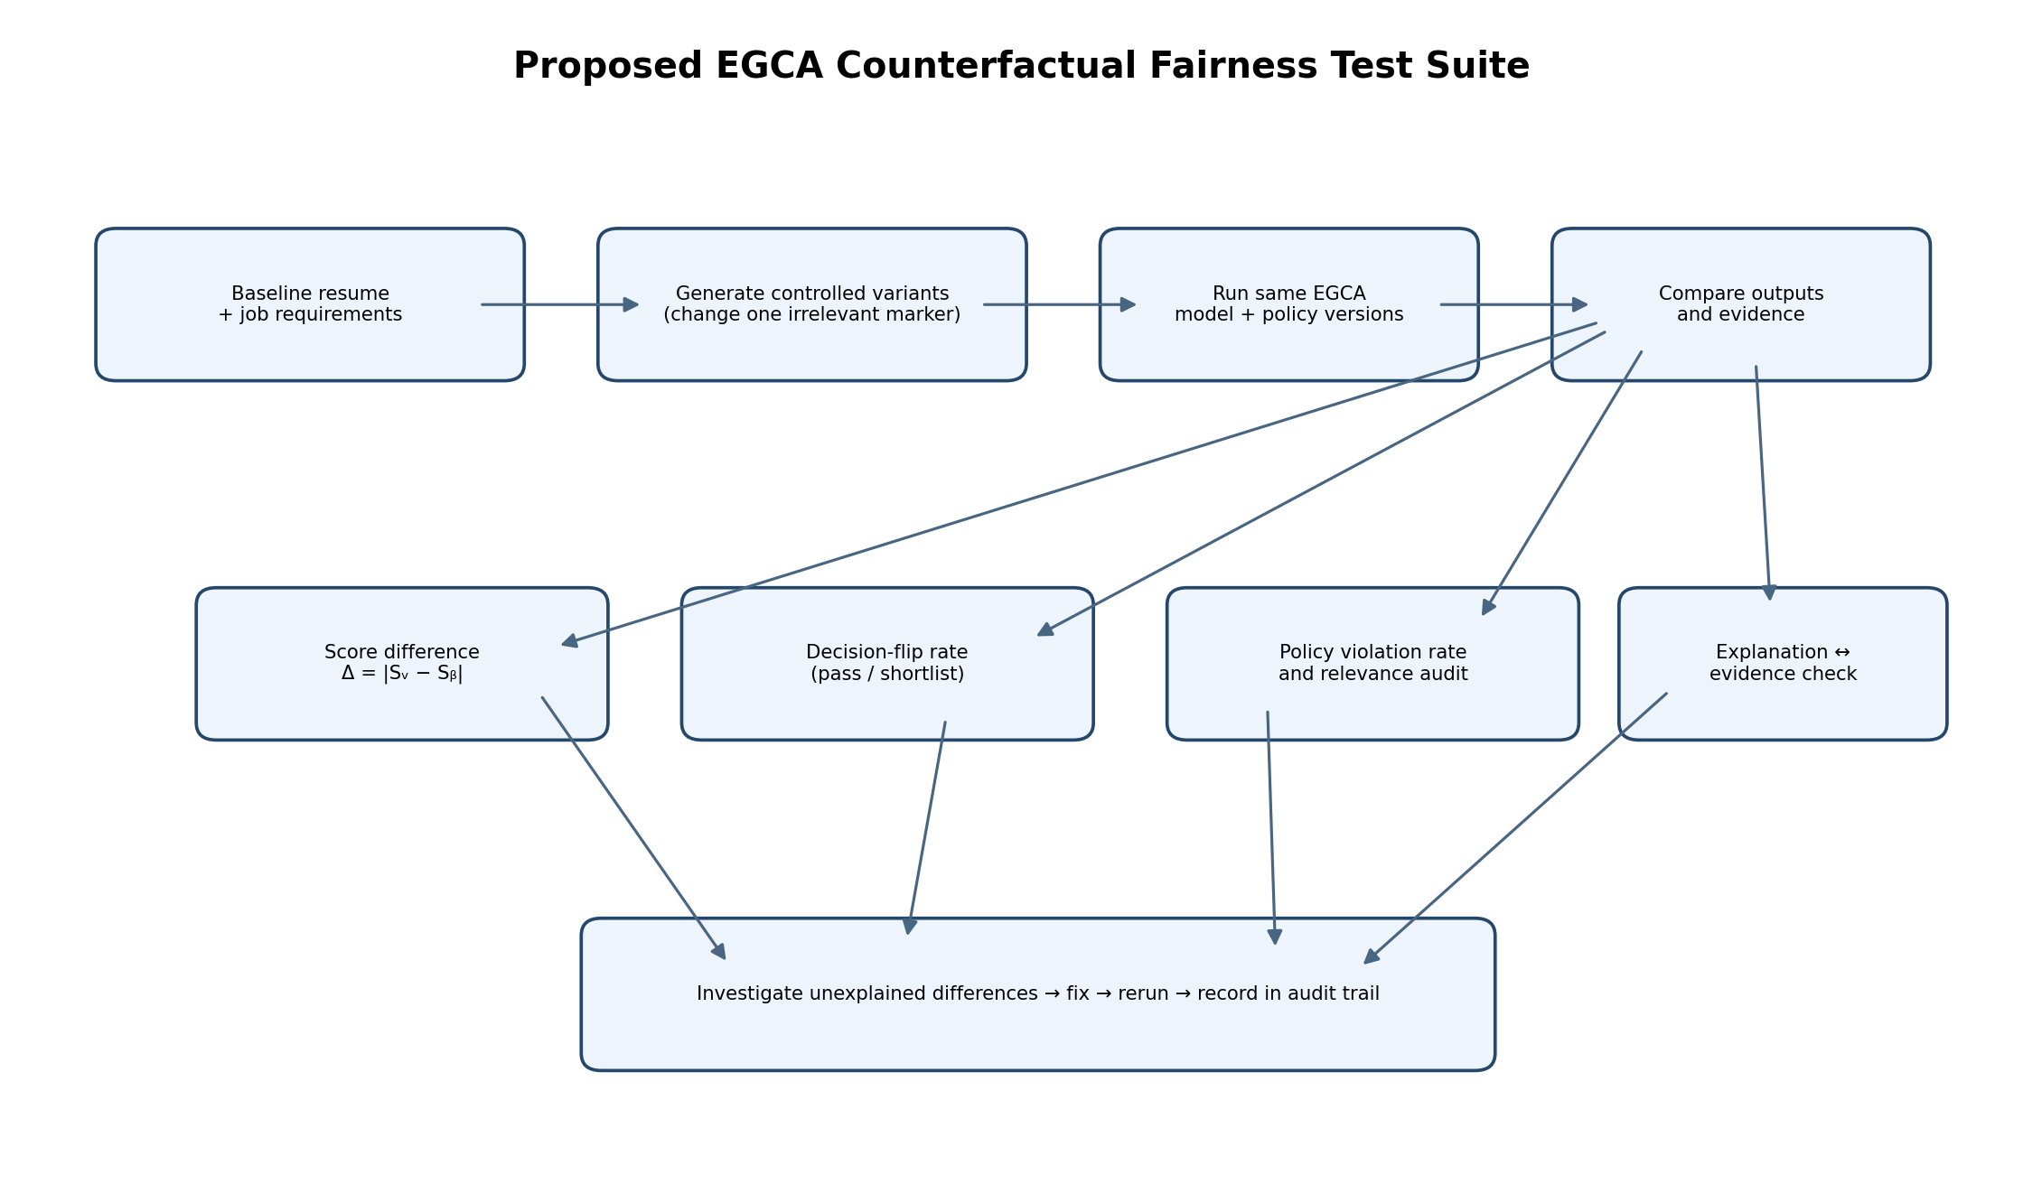

9.4 Proposed change D — Policy enforcement, not just prompt instructions
Why: The paper found that rationale prompting was not a dependable fairness intervention, and alternative prompts did not fully remove outcome patterns.
How: Treat the LLM as a component that extracts or organises evidence, while deterministic policy code governs which evidence may affect scoring. The scoring layer should reject excluded evidence and record policy decisions.
Expected impact: Moves fairness controls from “please be fair” wording into explicit, testable system rules. Rules can still be incomplete or incorrectly designed, so they require review.

9.5 Proposed change E — Fairness audit report and AuditTrailLog
Why: If a test fails, EGCA needs to know which input variant, model version, evidence item, rule, and score caused the discrepancy.
How: Record experiment ID, resume variant ID, job ID, model/version, prompt hash or version, policy version, evidence references, output scores, decision, metric results, and reviewer disposition.
Expected impact: Reproducibility, traceability, and faster root-cause analysis. Avoid storing unnecessary sensitive demographic data in production logs.

9.6 Proposed change F — Uncertainty routing and human review
Why: A counterfactual difference is a signal to investigate, not automatic proof of discrimination. Some differences may arise from job-relevant evidence or data quality.
How: Route unexplained score/decision changes, unsupported evidence, policy conflicts, or near-cutoff cases for review. Keep the reason and resolution in the audit record.
Expected impact: Prevents the system from pretending that every automated outcome is certain and creates a governed path to resolve exceptions.
Proposal | Why it follows from the paper | Potential EGCA impact | Validation needed
JobRelevanceGate | Irrelevant markers may influence model outputs | Restricts score-bearing evidence to job requirements | Measure excluded-evidence leakage and policy violations
Evidence provenance | Rationales are not proof of causal fairness | Trace scores to source evidence | Audit source coverage and unsupported claims
Counterfactual suite | Controlled variants reveal marker sensitivity | Repeatable fairness regression tests | Compare score deltas and decision flips
Policy enforcement | Prompt-only intervention is unreliable | Explicit rules control score eligibility | Test rule completeness and bypasses
Fairness audit report | Findings vary by model/task | Reproducibility and root-cause analysis | Rerun same test across versions
Uncertainty routing | Observed difference needs investigation | Human review for ambiguous cases | Track review accuracy, burden, and resolution

10. Proposed EGCA Architecture and Evaluation Plan
The following diagram integrates the existing EGCA phases with the proposed fairness controls. It is a design proposal, not a claim that these additions are already implemented.
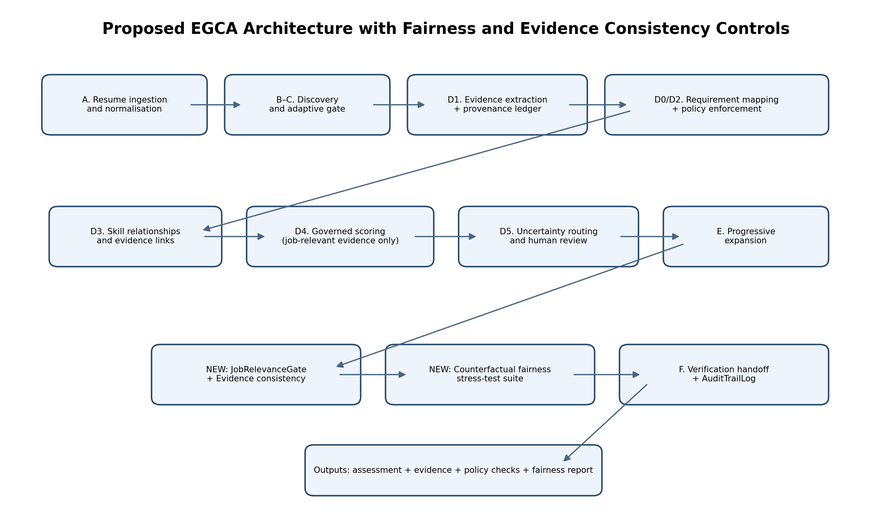

10.1 Architecture components
Component | Responsibility | New or existing
A. Resume ingestion | Parse, normalise, and preserve source provenance | Existing
B–C. Discovery/adaptive gate | Identify requirements and decide which assessment path applies | Existing
D0. Decisive requirements | Represent required/critical conditions | Existing
D1. Evidence extraction | Extract candidate claims and link to source spans | Existing; strengthen provenance
D2. Mandatory policies | Apply hard constraints and excluded-evidence rules | Existing; add relevance policy
D3. Skill relationships | Map evidence to skills and requirements | Existing
D4. Governed scoring | Calculate score using eligible evidence | Existing; enforce relevance gate
D5. Uncertainty routing | Route unclear or conflicting cases for review | Existing; include fairness flags
E. Progressive expansion | Expand assessment only when needed | Existing
F. Verification handoff | Provide evidence and checks for verification | Existing
JobRelevanceGate | Block irrelevant or disallowed evidence from scoring | Proposed
Counterfactual test suite | Compare controlled variants across outputs | Proposed
AuditTrailLog extension | Persist model, prompt, policy, evidence, and fairness metrics | Proposed extension

10.2 Suggested fairness metrics for EGCA
Metric | Formula / definition | How to interpret
Absolute score difference | Δᵢ = |S_variant − S_baseline| | A non-zero value triggers review if the changed feature was job-irrelevant.
Decision-flip rate | Number of variant pairs with different decisions ÷ all tested pairs | Shows how often irrelevant changes alter pass/shortlist outcomes.
Requirement-score consistency | Compare each job-requirement score across variants | Finds localised effects hidden by the overall score.
Evidence consistency | Compare evidence IDs, source spans, and status across variants | Flags new claims or lost evidence caused by irrelevant changes.
Policy violation rate | Excluded items affecting score ÷ tested excluded items | Checks whether the policy gate is actually enforced.
Explanation–evidence consistency | Share of rationale claims traceable to evidence and a requirement | Checks groundedness; does not prove absence of bias.
Group selection-rate difference | Compare selection rates across appropriate evaluation groups | Useful only with suitable data, context, privacy, and legal review.

10.3 Proposed acceptance criteria
Set acceptance criteria before running experiments to avoid choosing thresholds after seeing the results. These are initial engineering suggestions, not standards mandated by the paper.
Check | Initial acceptance rule to evaluate | What happens on failure
Irrelevant marker score delta | Target zero where the scoring method is deterministic and the qualification evidence is identical; otherwise define a justified tolerance | Trace output differences to evidence, prompt, policy, and model behaviour.
Decision stability | No pass/fail or shortlist flip caused only by an irrelevant marker | Block release or require documented review until explained.
Evidence provenance | Every score-bearing reason maps to a source and requirement | Reject unsupported reason from scoring; flag for review.
Excluded-evidence policy | No explicitly excluded evidence may affect score | Fail the policy test and fix the scoring path.
Repeatability | Same versions/configuration reproduce the same result within defined tolerance | Check nondeterminism, version drift, and hidden inputs.
Audit completeness | All required experiment and configuration fields are recorded | Do not mark the run complete.

Important: exact-zero score difference is a useful target for a fully deterministic, controlled comparison, but real LLM pipelines may be nondeterministic. If EGCA uses probabilistic components, define a tolerance and repeated-run analysis in advance.

11. Implementation Roadmap and Acceptance Criteria
Phase | Work | Deliverable | Exit condition
1. Baseline | Freeze EGCA model, prompt, policy, and scoring versions | Baseline assessment report | Reproducible baseline stored
2. Test data | Create synthetic resumes with job-relevant evidence and controlled irrelevant variants | Versioned test set and variant manifest | Qualifications remain identical across variants
3. Instrumentation | Record evidence IDs, source spans, requirement IDs, and score contributions | Evidence/provenance ledger | Every score-bearing reason traceable
4. Relevance gate | Implement and unit-test score eligibility rules | JobRelevanceGate module and tests | Irrelevant evidence cannot enter score path
5. Counterfactual runner | Run paired variants under identical configuration | Experiment runner | All variants and outputs recorded
6. Metrics | Calculate score deltas, decision flips, evidence consistency, policy violations | Metrics report | Metrics match hand-checked test cases
7. Review workflow | Route unexplained changes to human review | Review queue and dispositions | Each flag has a resolution record
8. Regression | Repeat after model, prompt, or policy updates | Version comparison report | Release gate passes or has documented exception

11.1 Example policy pseudocode
The following snippet is illustrative pseudocode. It must be adapted to the real EGCA schema and security requirements before production use.
def can_affect_score(evidence):
if not evidence.source:
return False
if not evidence.supports_job_requirement:
return False
if evidence.status == "INFERRED":
return False
if evidence.policy_status == "EXCLUDED":
return False
return True

11.2 Example experiment
Resume version | Qualifications | Irrelevant detail | Score | Decision
Baseline A | Python, SQL, 3 years, two projects | Hobby A | 82 | Shortlist
Variant B | Same evidence and qualifications | Hobby B | 82 | Shortlist
Variant C | Same evidence and qualifications | Marker C | 76 | Not shortlisted

In this illustrative example, Variant C differs only in an irrelevant marker but receives a lower score and changes the shortlist outcome. EGCA should flag it, trace the change, and investigate. These values are examples, not measured results.

12. Questions for Revision and Oral Explanation

Q1. What is the central research problem?
Subtle sociocultural markers may allow demographic inference and affect hiring outcomes after direct identifiers are removed.

Q2. Why is anonymisation insufficient?
It removes names and direct identifiers but may leave indirect demographic proxies.

Q3. How many resumes were used?
4,100: 100 neutral baselines and 4,000 variants.

Q4. What were the two hiring tasks?
Direct Comparison and Score & Shortlist.

Q5. What was the main ethnicity ablation finding?
Removing language markers reduced Gemini 3 Flash ethnicity macro-F1 from 0.972 to 0.130.

Q6. What was the main gender ablation finding?
Activities, volunteering, and hobbies raised gender classification F1 to 0.980 in the reported Gemini 3 Flash sequence.

Q7. Did rationale prompting solve the problem?
No. It was not a dependable fairness intervention; aggregate metrics worsened, but effects varied and no consistent direction was statistically established across all models.

Q8. What is the main limitation?
Synthetic, Singapore-oriented, stereotypical markers and a limited experimental setup do not directly estimate real-world discrimination rates.

Q9. What should EGCA add?
Job relevance gating, evidence provenance, counterfactual fairness testing, policy enforcement, audit reporting, and uncertainty routing.

Q10. How would EGCA prove improvement?
Compare a baseline screener and EGCA variants on controlled test cases using predeclared metrics and repeatable experiments.

Glossary
Term | Plain-language definition
Ablation study | Remove one part of an input and measure what changes.
Anonymisation | Removing direct identifiers from data.
Bootstrap | Repeatedly resample observed data to estimate uncertainty.
Ceiling effect | When scores are already at the maximum, making improvement hard to detect.
Confound | A factor that may offer another explanation for an observed result.
Counterfactual | A controlled alternative version used to test what changes when one factor changes.
F1 | A combined measure of precision and recall.
Macro-F1 | Average F1 across classes, giving each class equal weight.
Intersectionality | Studying combined group categories rather than only one attribute at a time.
LLM | Large Language Model; an AI system that processes and generates text.
Proxy | Indirect signal associated with a characteristic.
Rationale prompting | Asking the model to provide a short explanation with its output.
Robustness | Whether a finding remains under alternative reasonable test conditions.
Synthetic data | Artificially generated data used for experiments.
Top-Score Rate | Measure of how often a demographic group receives the top score in the study's setup.
Win rate | How often a variant is selected over its paired neutral baseline.

References and Verification Notes
Primary paper: “Small Changes, Big Impact: Demographic Bias in LLM-Based Hiring Through Subtle Sociocultural Markers in Anonymised Resumes.”
Paper HTML: https://arxiv.org/html/2603.05189
Authors' research repository: https://github.com/Social-AI-Studio/LLMHiringFairnessSG
The paper is the source for the study's reported dataset, experiments, metrics, and findings. The EGCA architecture extensions, proposed metrics, sample pseudocode, implementation roadmap, and acceptance criteria in this report are recommendations for future work; they are not reported experimental results from the paper.
Before citing this report academically, verify the current paper version and repository materials. In particular, check detailed model-level tables and any version-specific changes in the source.

Final Takeaway
The paper's central lesson is that removing a name does not guarantee fair treatment. Indirect clues can remain, and asking a model to explain itself does not reliably remove their influence. EGCA can use this lesson by controlling which evidence is allowed to affect scores, testing controlled resume variants, measuring score and decision stability, and recording the results so that unexplained differences can be investigated.

